Idea Proposal

**1. What is the name of the app you want to develop? (Tentative name)**

a. MathClock

**2. What is/are the problem/s you want to solve?**

b. The normal alarm clock will stop ringing when being turned off, people with low willpower may just turn it off and go back to sleep.

**3. Who are the users you are targeting?**

c. People who have trouble waking up

d. people who want their brain to be refreshed and waken

e. Students

**4. How will this app solve the tackled problem/s? Provide a vision statement.**

f. The alarm will not stop until you have answered the question correctly, you will absolutely be awake whether you have figured it out or not.

g. Students can use this app to warm up their mind before going to school

**5. What are the major features of the app?**

h. Different types of alarm music as options when setting up the alarm

i. Powerful

ii. lively

iii. soft

i. You can choose math problems of different difficulty when setting up the alarm

**6. How is this app unique? Why do users need this app?**

This application can help the users to learn mathematics knowledge in an interesting way. Math is a difficult subject for a lot of people. It’s totally understandable. People look for math app but most of them are educational.

**7. What are the risks associated with the development of this app? Why wouldn’t it be delivered completely (scope), on time and on budget? Identify 3 to 5 risks that are relevant in your case.**

It might be a challenge to develop the random math problem future to keep the problems new for the user.

Risks:

1. App does not switch off sound after problem is solved (possible bug).

2. The user knows the answer to the math problem (hence a random number generator would have to be used).

3. The alarm does not ring (possible glitch)

**8. What similar apps exist on the market? (at least 5 apps with names, screenshots, links, descriptions and how different they are)**

1. Wabbitemu

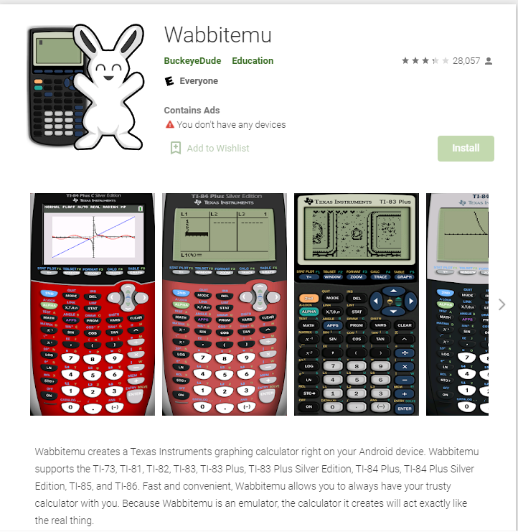

[**https://play.google.com/store/apps/details?id=com.Revsoft.Wabbitemu&hl=en_US&gl=US**](https://play.google.com/store/apps/details?id=com.Revsoft.Wabbitemu&hl=en_US&gl=US)

1. Khan Academy

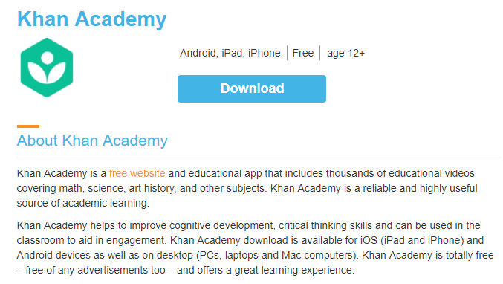

[**https://play.google.com/store/apps/details?id=org.khanacademy.android**](https://play.google.com/store/apps/details?id=org.khanacademy.android)

1. Star Dash Studio

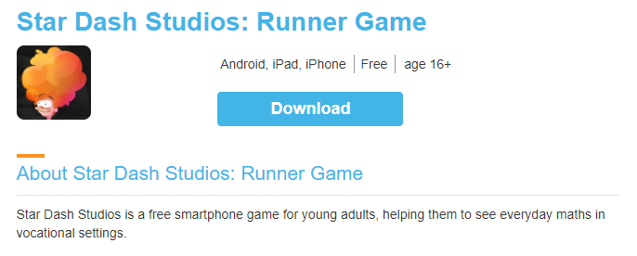

[**https://play.google.com/store/apps/details?id=uk.org.nationalnumeracy.stardashstudios&hl=en_US&gl=US**](https://play.google.com/store/apps/details?id=uk.org.nationalnumeracy.stardashstudios&hl=en_US&gl=US)

1. SumQuest

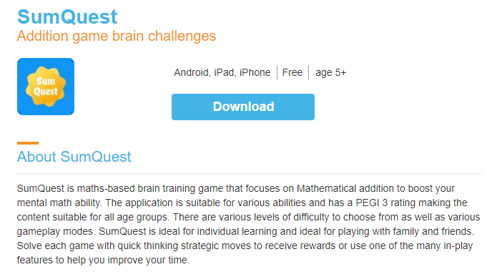

[**http://sumquest.co.za/**](http://sumquest.co.za/)

1. King of Math

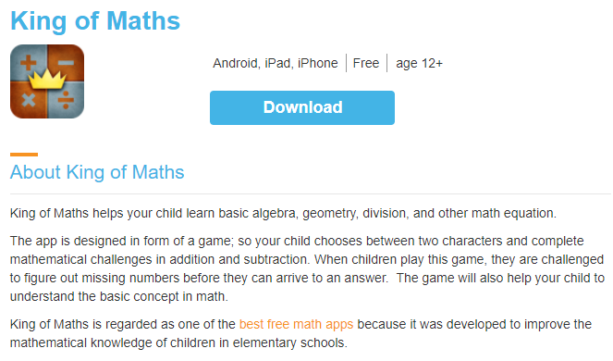

**https://play.google.com/store/apps/details?id=com.oddrobo.kom&hl=en_US&gl=US**